**EIR Operational Manual**

|  |  |  |  |  |  |
| --- | --- | --- | --- | --- | --- |
| **Corporate Function / Department**  EDO | | **Subject**  EIR Data Imports into Zone2 | | | |
| **Distribution** | **Version**  1.0 | | **Procedure Number** | | **Effective Date**  10/9/2017 |
| **Issued By** | | | **Type**  Procedure | **Level**  IV | **Last Review**  Hive Admins Only |
| **Approvals** | | | | | **Next Review**  Hive Admins Only |

***Printed copies are for reference only. Please refer to the electronic copy for the latest version.***

1. Purpose 2

2. Scope 2

3. Prerequisites 2

4. Applicable Systems 2

5. Process Flow 3

6. Procedures ……..4

*6.1 CA-7 Procedures* 4

*6.2 PSO Instruction* 5

7. SLA Details. 6

8. Key Performance and Key Risk Indicators (KPI & KRI) 6

9. Controls 6

10. References and Related Documents 6

13. Points of Contact 6

# Purpose

The purpose of this document is to specify the ingestion of data, data modeling and analytics of Marketing EIR, MDM and SAS Data on Zone 2 discovery environment in Atlas Data Lake

# 2. Scope

Scope of this framework is to detail the step by step procedures followed during execution of EIR,MDM and SAS workflow for importing source applications into zone2 discovery cluster.

# 3. Prerequisites

The source files should be available from the corresponding source systems (SAS Grid and PDOA). DBA team will enable option to provide Date and timestamp field in hive appropriate while extracting EIR db2 data.

Db2 Database ‘Time’ datatype is saved as ‘String’ datatype into hive tables, as hive doesn’t support ‘Time’ datatype.

# 4. Applicable Systems

|  |  |  |  |  |
| --- | --- | --- | --- | --- |
| * **S.No** | * **System** | * **Definition** | * **Source System** | * **Frequency** |
| * 1. | * Atlas | * Atlas Data Lake |  |  |
| * 2. | * EIR | Enterprise Information Repository | * PDOA | * Daily |
| * 3. | * MDM | * Marketing Data mart  1. Account - T_ACCT_DIM 2. House Hold - T_HH_DIM 3. Client Relationship - T_CIN_XREF | * MDM Snapshot | * Monthly |
| * 4. | * SAS | * Statistical Analysis System | * SAS Grid | * Monthly |

# 5. Process Flow

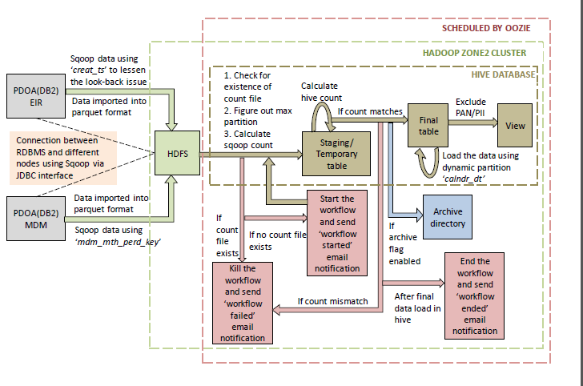

# 6. Procedures

## *6.1* CA-7 Procedures

|  |  |  |  |
| --- | --- | --- | --- |
| **S.No** | **Process** | **Step description** | **Attachments** |
| 1. | Check the  Availability of Scripts file | Run_me.sh script should be available at the path **/zone2/ae/marketing/eir/** for EIR,MDM,SAS as well as Rest of scripts should be present in hdfs at **hdfs://user/uzlweir1/** |  |
| 2. | CA-7 trigerred | 1. CA7 job should start. 2. Oozie-start email notification should be received. 3. CA7 job should trigger workflow at specific scheduled time. 4. Triggered workflow should complete successfully. 5. Oozie-end email notification should be received. 6. CA7 job should complete successfully. |  |
| 3. | EIR & MDM Workflow | **Workflow Details:**   1. Shell-entry 2. Hive-max-check 3. Shell Evaluate 4. Sqoop-load 5. Hive Staging Load 6. Decision-check 7. Hive-load 8. Data-archive |  |
| 4. | SAS Workflow | **Workflow Details:**   1. Entry.sh 2. Data Availabilty Check 3. Hive_Load.hql 4. Hive_Eval.sh 5. Data_archive.sh |  |

## *6.2* PSO Instruction

|  |  |  |  |
| --- | --- | --- | --- |
| **S.No** | **Process** | **Instruction** | **Attachment** |
| 1. | Schedule Instructions | 1. Login using new process ID with credentials defined. 2. CD /home/processID/sqoop_load 3. Schedule the sqoop_oozie coordinator using attached unix command |  |
| 2. | Oozie Action Email-Start | 1. Run_me.sh script will trigger oozie workflows and send an Email alert to USERS/PSO with initiation of sqoop import. 2. The start email will provide you oozie workflow name, Workflow id and URL to track on job progress status. 3. Also PSO can refer the job progress using command line with oozie command listed in the email. |  |
| 3. | Oozie Action Email-End | 1. Once all oozie actions completed successfully will trigger an email end action. 2. The Email contains Workflow name,Job Name,Workflow ID, Sqoop,Hive Count with Validation Status and URL to track job progress status. |  |
| 4. | Oozie Action Email-Fail | 1. If oozie job failed or interrupted between running actions, it will trigger an email with failure instructions. 2. The Email contains Error code,debug url to analyze the error and Commands to rerun or start from failed action. |  |

# SLA Details

|  |  |
| --- | --- |
| **SLA Instruction** | **Time** |
| SLA For Daily Load * | 5 PM EST |
| SLA For Ondemand Load * | NA |
| SLA For Monthly Load * | 11:00 AM IST |
| Days of the run (BD, Weekdays) * | All Calendar Days |
| Starting Job of the load * |  |

# 8. Key Performance and Key Risk Indicators (KPI & KRI)

There is no Key Performance and Key Risk Indicators for this procedure.

# 9. Controls

Please contact the Operational Risk Officer for information regarding controls.

# 10. References and Related Documents

<http://epr2.suntrust.com/sites/pr201603/ST2015003166_AnalyticsPOCPrepandSupport/_layouts/15/start.aspx#/ProjectArtifacts/Forms/AllItems.aspx>

# 11. Points of Contact

|  |  |  |
| --- | --- | --- |
| **Contact** | **Primary Contact** | **Secondary Contact** |
| Business Contacts for sending Delay Notification | [Brian.Kramer@SunTrust.com](mailto:Brian.Kramer@SunTrust.com) |  |
| PSO Contacts | [DL.PSO.ATLAS-DataLake@SunTrust.com](mailto:DL.PSO.ATLAS-DataLake@SunTrust.com) |  |
| Onsite Development/CD Team Contacts | [Sathish.Mani@SunTrust.com](mailto:Sathish.Mani@SunTrust.com) | [Ganesh.Gurusiddaiah@SunTrust.com](mailto:Ganesh.Gurusiddaiah@SunTrust.com) |
| Offshore Development/CD Team Contacts | [Nikhila_Kamat@SunTrust.com](mailto:Nikhila_Kamat@SunTrust.com) |  |
| Hive Administrator | [Dharmendra.K.Shavkani@SunTrust.com](mailto:Dharmendra.K.Shavkani@SunTrust.com) |  |

|  |  |  |
| --- | --- | --- |
| **Upstream/Downstream Interfaces** | | |
| Upstream Contact Details and ITSP Group Name |  |  |
| List of Downstream Applications | [Brian.Kramer@SunTrust.com](mailto:Brian.Kramer@SunTrust.com) |  |